# Example of Testing Table Layout

|  |  |  |  |  |
| --- | --- | --- | --- | --- |
| **Test Number** | **Description** | **User Input** | **Expected Output** | **Actual Output**  **Image no.** |
| **1** | Splash screen | User starts program splash screen appears | Splash screen should appear for 6 seconds and then go to the options menu | 1  2 |
| **2** | Getting to the game | User presses start | Starts the game | 3 |
| **3** | Getting an answer correct | User gets the correct answer | Users get a tick and 1 point  User previous answer gets clears so user can answer next anagram  User gets a new anagram to solve | 4 |
| **4** | Getting the answer incorrect | User get the incorrect answer | User receives 0 points  User previous answer gets clears so user can answer the same anagram  User receive an X | 5 |
| **5** | Time Runs out | User runs out of time | User gets a pop-up asking if they would like to play again | 6 |
| **6** | Pop-up options | Users presses No | User will receive an another pop-up that will say thanks for playing and will exit the program | 7 |
| **7** | Pop-up options | User presses Yes | The game will reset and the user will be able to play again | 8 |
| **8** | Entering admin login | User presses admin login on the options menu | Present login and password for the user to enter | 9a |
| **9** | Enter admin details | User enters incorrect admin login information | User will receive a pop-up saying incorrect user name | 9 |
| **10** | Enter admin details | User enters the correct admin details | User will be directed to the admin options form | 10 |
| **11** | Add, edit, delete buttons | User press 3 buttons | When user presses buttons  Add button reveals textboxes and labels  Edit button reveals textbox labels  When either add or edit are pressed a key on the far right show what the text boxes represent only for them  Delete button revels  A text box and labels | 11  12  13 |
| **12** | Add new info | User enters all information  Press add under the text boxes | Users information is added to the rich text box  Add section goes invisible until add button is press main add button | 14  15 |
| **13** | Edit current info | User enters a number to select form the rich text box  If user enters an invalid number user is presented with a pop-up  If user enters valid number 3 more text boxes appear  Information all input will change the text in the rich text box | User enters a number to select form the rich text box  If user enters an invalid number user is presented with a pop-up  If user enters valid number 3 more text boxes appear  Information all input will change the text in the rich text box  Multiple uses of main edit causes override of no.1 if ok isn’t pressed | 16  17 |
| **14** | Delete current info | User presses main delete  Shows a text box  And label to explain to delete a number in the rich text box  User types number to delete  Number is deleted | User presses main delete  Shows a text box  And label to explain to delete a number in the rich text box  User types number to delete  Number is deleted | 18  19  20 |
| **15** | File .txt updating | When user enters information it update .txt file | When user enters information it update .txt file | 21  22 |
| **16** | Exit programme main menu | Hitting exit button exits application | Hitting exit button exits application | - |

1

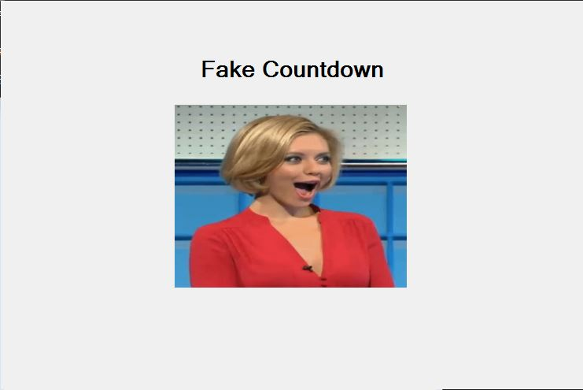

2

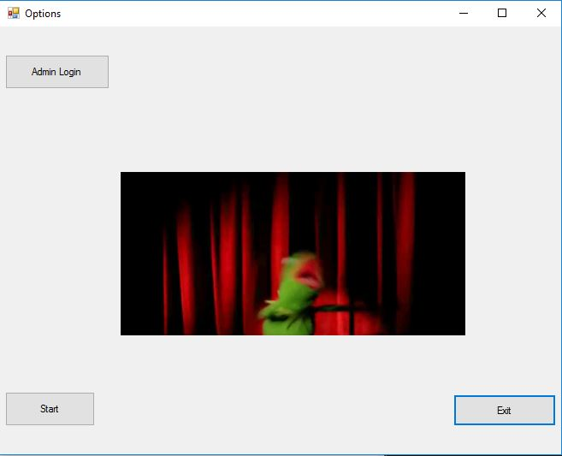

3

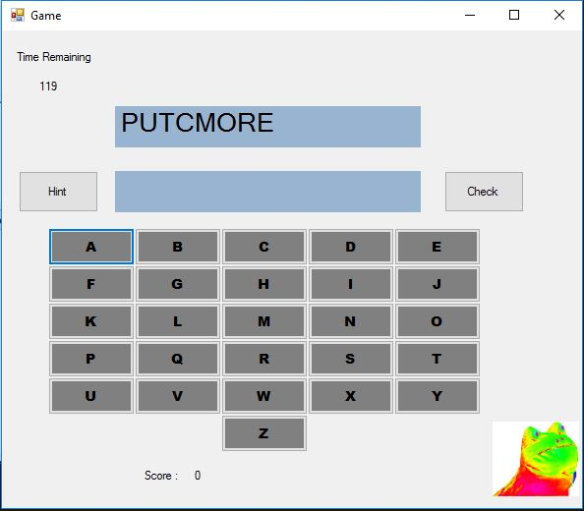

4

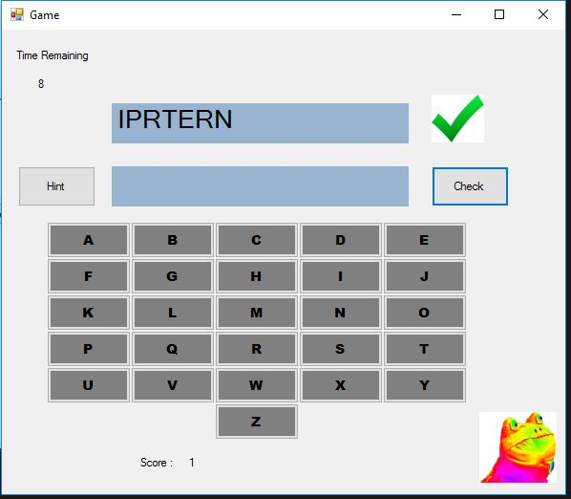

5

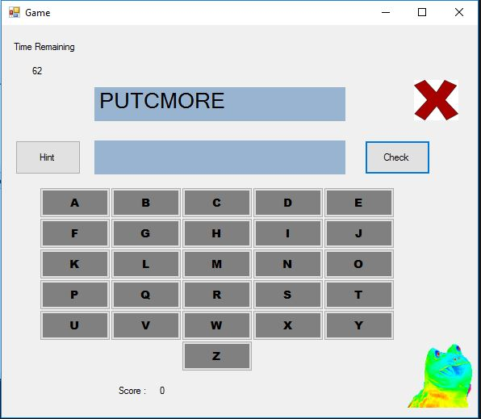

6

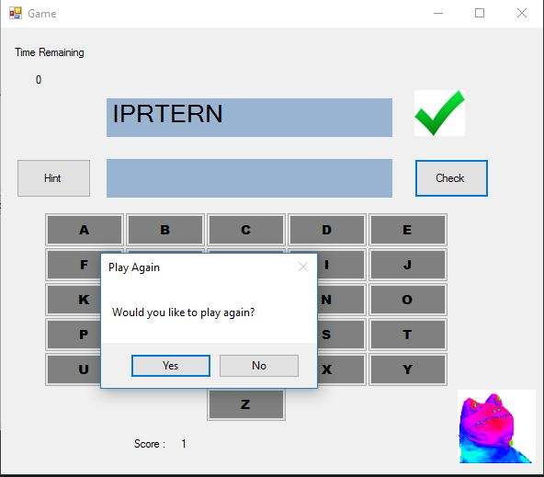

7

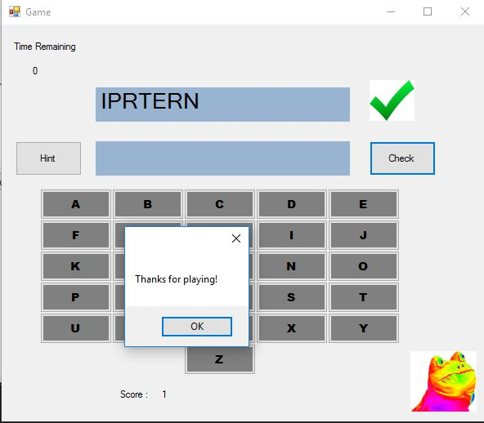

8

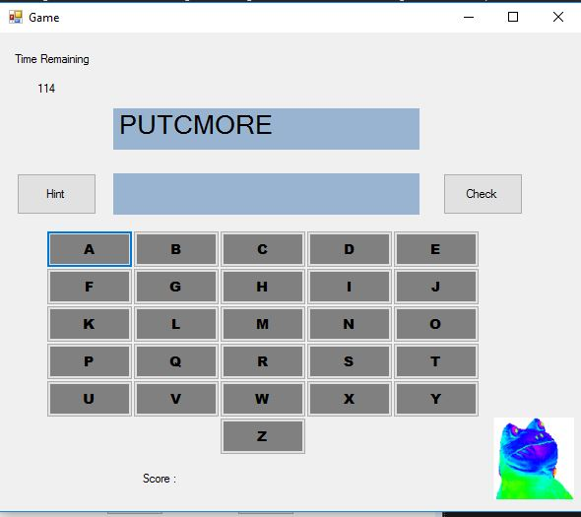

9a

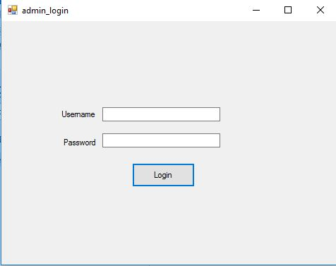

9

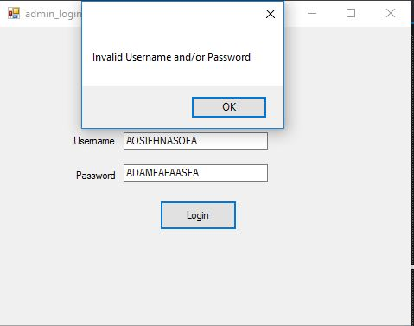

10

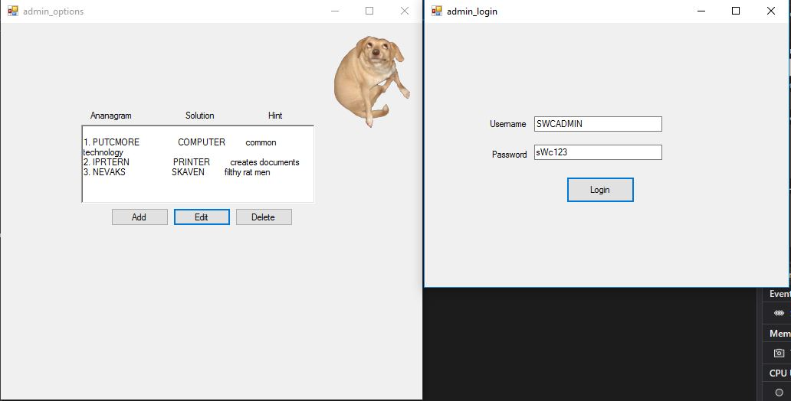

11

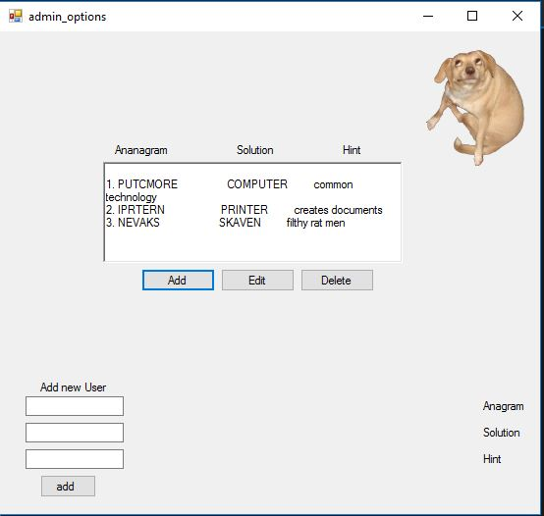

12

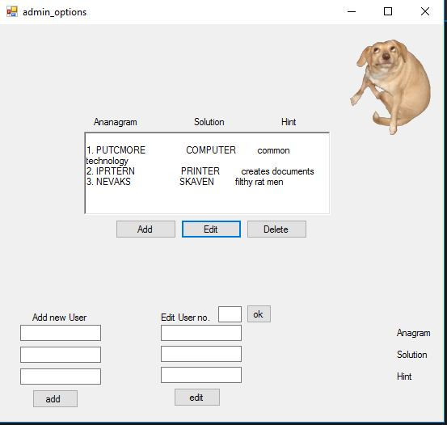

13

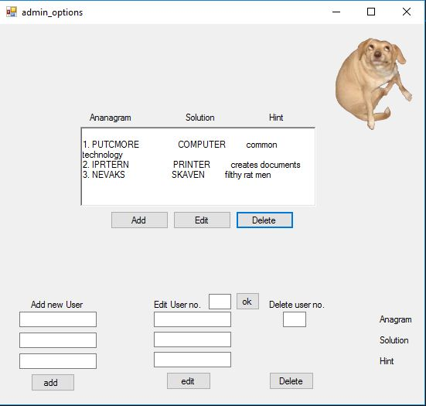

14

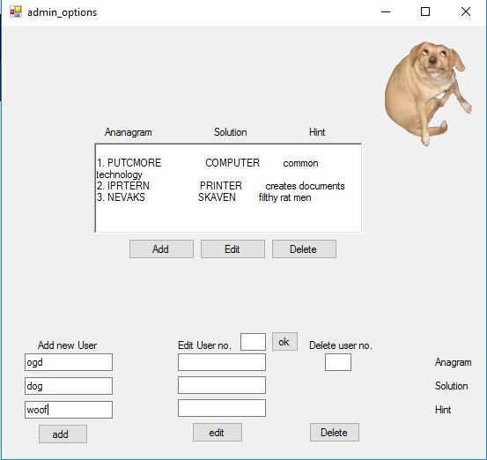

15

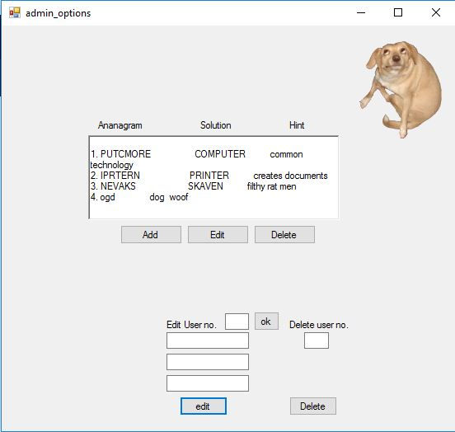

16

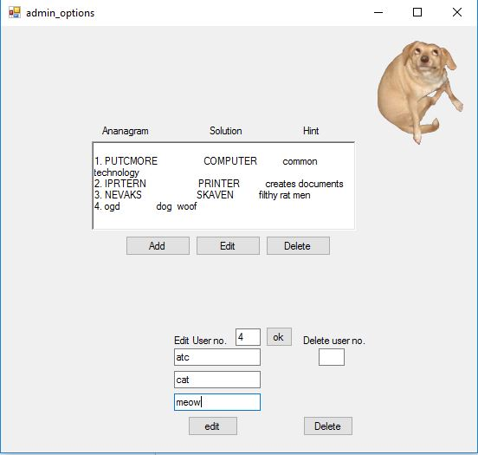

17

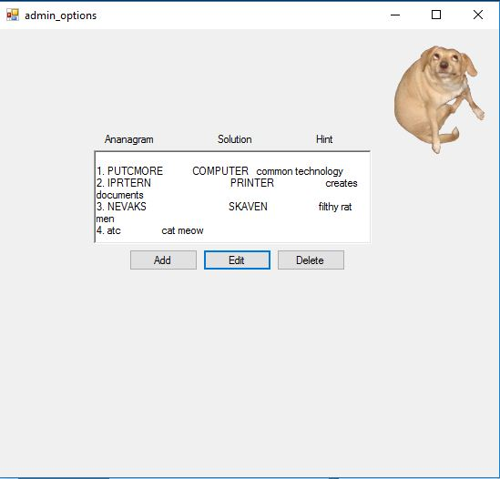

18

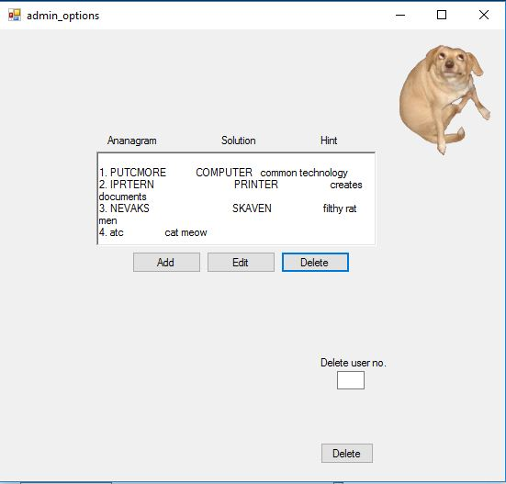

19

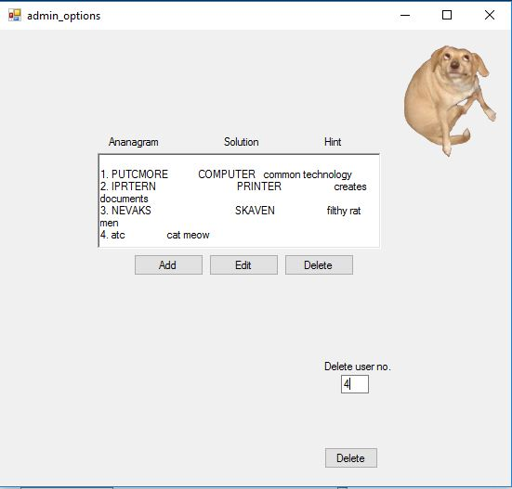

20

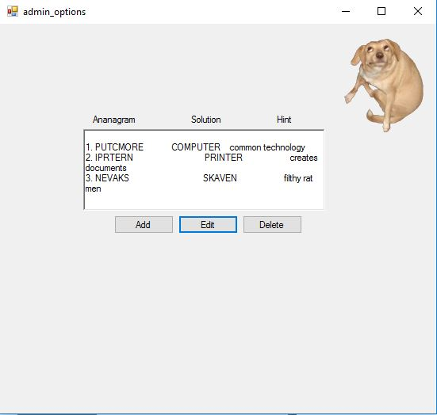

21

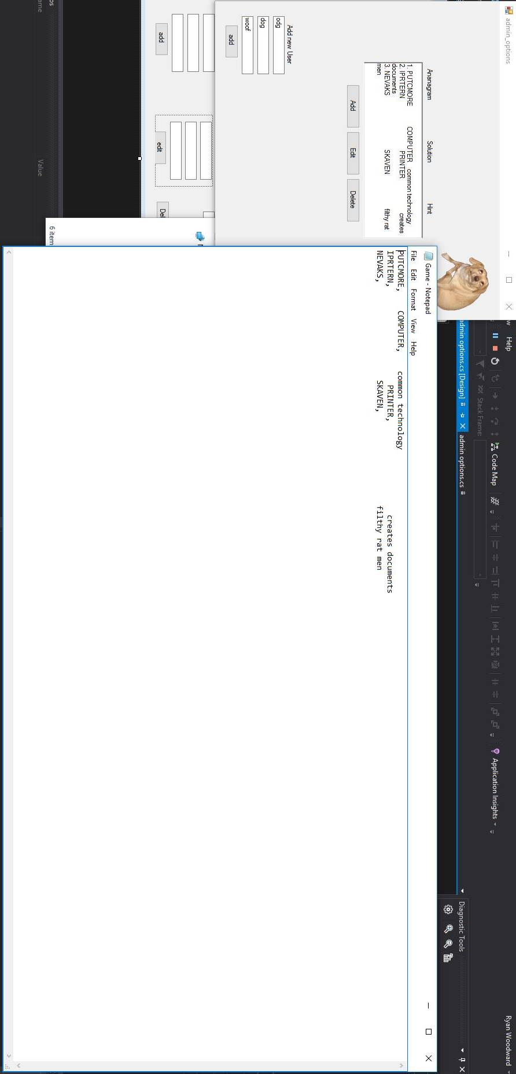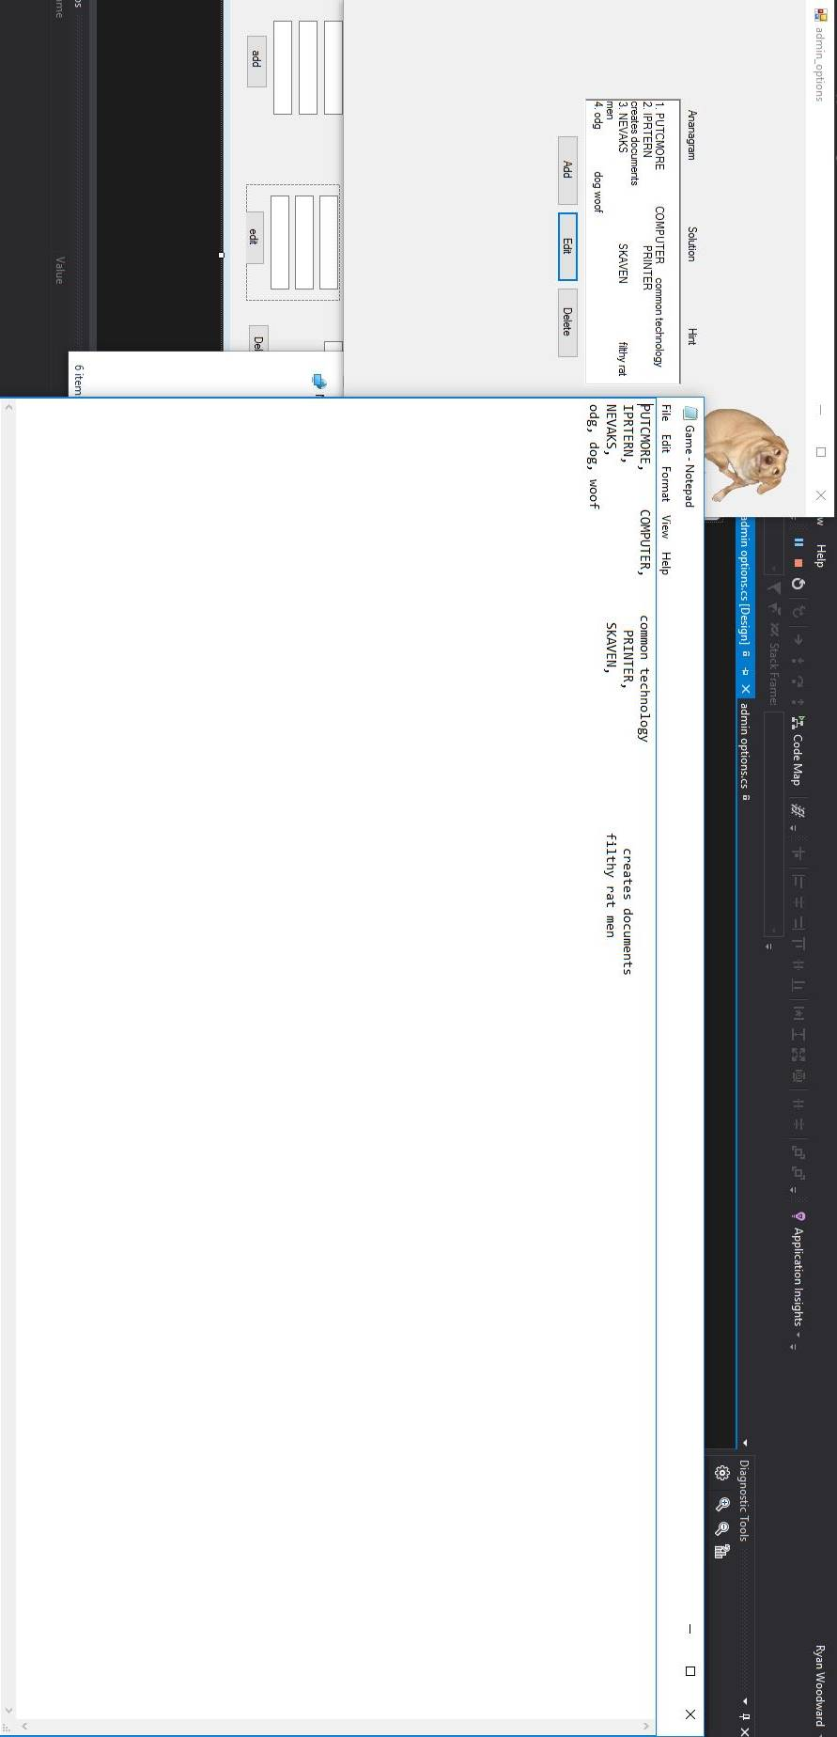

22